Note: Include this page only when adding / amending / deleting a document. If using this document as a record, this Revision History page can be omitted.

REVISION HISTORY

Revision no | Date | Description of Changes | Reason for Revision | Revised by | Approved by
2 | 08 May 13 | Add revision history page  Added Notes | - Recommendation from Stage 2 audit | RDPlacido  WRRobles
3 | 02 June 2014 | Some revisions in flow chart and added notes | Improvement | WRRobles
4 | Apr. 8, 2016 | Added disclaimer when printing the document | For document control | RCGanal | WRRobles
5 | 16 Aug 2016 | Update notes and references | Improvement | MCDy | WRRobles
6 | 02 March 2018 | Change AP Accountant to Finance Associate (FA) | To conform to current title | WRRobles | WRRobles
TM-BR-MG- 11 Rev02, 10302015

- Objective

To support operational requirements of the company by buying products and services at the right price, from the right source, at the right specifications that meet user’s needs, in the right quantity and at the right time.

- Scope

This procedure defines the actions and responsibilities of the Requestor, Finance Associate, Finance Head and Execom in purchasing procedure. This covers activities from receiving the Request to Purchase to delivery of the item/s requested.

- Definition of Terms

Request to Purchase | Document submitted by Requestor containing the purchase requirements (specifications) and the approval of the Unit Head/Mancom.
Quotation | Proposal from accredited supplier pertaining to the Request to Purchase. It contains the item specifications, cost, terms and conditions of payment
Comparative Quote Report | Document prepared to compare, analyze and to select the best quote
Purchase Order | A legally binding document that specifies item ordered from a supplier for an indicated price
Delivery Receipt | The proof of delivery by the supplier and receipt of the customer of a particular item
SFARA | Statement of Fixed Asset Responsibility and Accountability is a document issued to and signed by the assignee upon receipt of fixed asset

- Procedure Details
RESPONSIBLE | ACTIVITY | INTERFACE
Finance Associate  Requestor/Finance Head/President  Finance Associate | 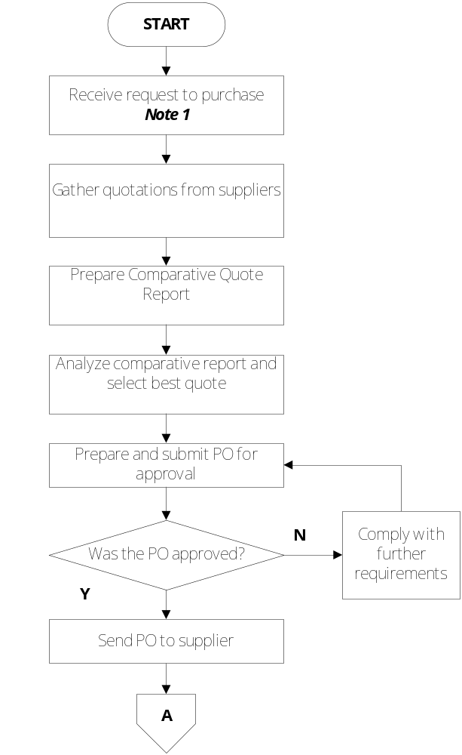 | Requestor/Unit Heads  Suppliers  Quotations  Comparative Quote Report  Approved Comparative Quote Report  Purchase Order  President  Supplier

RESPONSIBLE | ACTIVITY | INTERFACE
Finance Associate | 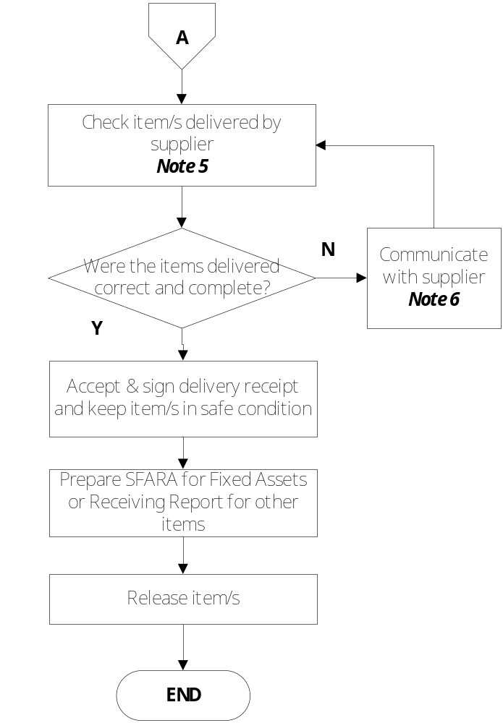 | Supplier  Hardware Equipment Inspection & Acceptance Form  Software Installation, Testing & Acceptance Form  Technical Support Staff  Delivery Receipt  SFARA  Request to Purchase –Receiving Report  Requestor

Notes:
- The Request to Purchase must be approved by the respective Unit Head and Execom.
- Procurement must be given enough time to source requested items. At least ten (10) working days shall be allotted for sourcing non-difficult-to- source item. Difficult to source items shall be requested at least one month before date needed. Items that are order basis (supplier’s delivery is dependent on the arrival of order) shall be exempted from counting of delays.
- When the RTP is urgent (must be delivered in less than 10 working days) or the total value of the RTP does not exceed P10,000, verbal quote from suppliers shall be acceptable.
- Make sure that quotations conform with the specifications written in Request to Purchase. Get quotations from at least two (2) suppliers.
- When the item requested is a repeat order (less than one month from last order), comparative quote may not be necessary. Procurement may order from the most recent supplier.
- If supplier for a particular product or service is exclusive or requestor has preferred supplier, no need to prepare Comparative Quote Report. Proceed to PO issuance upon review of quotation.
- Include the requestor when analyzing the Comparative Quote Report. The Finance Head and President must approve the Comparative Quote Report.
- If the specification requested is not available, inform the requestor immediately. He may issue a new RTP for alternative specs. The previous RTP must be cancelled.
- Verification of purchased product
Upon delivery of the product, inspect the item if it conforms to the specs written in the PO. Critical equipment such as desktop, laptop, computer accessories & software shall be inspected by the Technical Support Staff. Use the forms Hardware Equipment Inspection and Acceptance Form (FO-FI-FI-30) and Software Installation, Testing & Acceptance Form (FO-FI-FI-31).
- Communicate immediately with supplier if items delivered are non-conformity with PO. Do not accept the items delivered until everything is resolved.

- References
  - Supplier Control Procedure Manual (PM-FI-FI-07)
  - Hardware Equipment Inspection and Acceptance Form (FO-FI-FI-30)
  - Software Installation, Testing & Acceptance Form (FO-FI-FI-31)

- Quality Records
- Request to Purchase
- Supplier’s Delivery Receipt or its equivalent
- Purchase Order
- Comparative Quote Report
- Hardware Equipment Inspection and Acceptance Form
- Software Installation, Testing & Acceptance Form
- SFARA
- Quotations from Vendors

